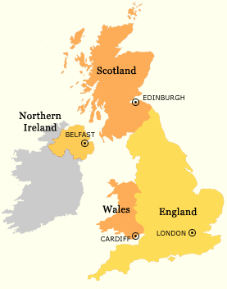
The Counties of the UK and Ireland (120)
The United Kingdom
England (43) | Scotland (33) | Wales (12) | Ireland (26)
The Shires:  Bedfordshire  Berkshire  Buckinghamshire  Cambridgeshire  Cheshire  Derbyshire  Gloucestershire  Hampshire  Herefordshire  Hertfordshire  Huntingdonshire  Lancashire  Leicestershire  Lincolnshire  Monmouthshire  Northamptonshire  North Yorkshire  Nottinghamshire  Oxfordshire  Shropshire  Staffordshire  South Yorkshire  Warwickshire  Wiltshire  Worcestershire *  Others:  Cornwall  Cumberland  Devon  Dorset  Durham  East Sussex  Essex  Greater London  Kent  Middlesex  Norfolk  Northumberland  Rutland  Somerset  Suffolk  Surrey  West Sussex  Westmorland | Aberdeenshire  Argyllshire  Ayrshire  Banffshire  Berwickshire  Clackmannanshire  Dunbartonshire  Dumfries-shire  Forfarshire  Inverness-shire  Kincardineshire  Kinross-shire  Kirkcudbrightshire  Lanarkshire  Peebles-shire  Perthshire  Renfrewshire  Roxburghshire  Selkirkshire  Stirlingshire  Wigtownshire  Bute  Caithness  East Lothian  Elgin  Fife  Midlothian  Nairn  Orkney  Ross and Cromarty  Shetland  Sutherland  West Lothian | Brecknockshire  Carmarthenshire  Caernarvonshire  Cardiganshire  Denbighshire  Glamorganshire  Merionethshire  Montgomeryshire  Pembrokeshire  Radnorshire  Anglesey  Flint | Carlow  Cavan  Clare  Cork  Donegal  Dublin  Galway  Kerry  Kildare  Kilkenny  Laois  Leitrim  Limerick  Longford  Louth  Mayo  Meath  Monaghan  Offaly  Roscommon  Sligo  Tipperary  Waterford  West Meath  Wexford  Wicklow
 |  | N. Ireland (6)
Antrim
Armagh
Down
Fermanagh
Londonderry
Tyrone

Suggested videos:
Main counties: https://www.instagram.com/reel/ChDWXImAPRU/?igshid=YmMyMTA2M2Y%3D (3 mins)
* Pronunciation: https://www.youtube.com/watch?v=xw7xy9LGyq0 (2 mins)
The Counties of England

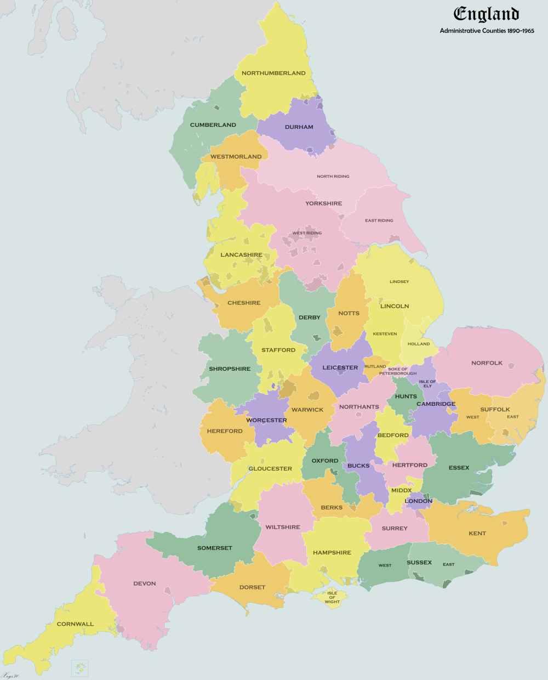
Principal Cities of the UK

London (Capital of England) | Lancaster
Birmingham | Oxford
Leeds | Newport
Glasgow | Preston
Sheffield | St Albans
Bradford | Norwich
Edinburgh (Capital of Scotland) | Chester
Liverpool | Cambridge
Manchester | Salisbury
Bristol | Exeter
Wakefield | Gloucester
Cardiff (Capital of Wales) | Lisburn
Coventry | Chelmsford
Nottingham | Chichester
Leicester | Winchester
Sunderland | Londonderry
Belfast (Capital of N. Ireland) | Carlisle
Newcastle upon Tyne | Worcester
Brighton | Bath
Hull | Durham
Plymouth | Lincoln
Stoke-on-Trent | Hereford
Wolverhampton | Armagh
Derby | Inverness
Swansea | Stirling
Southampton | Canterbury
Salford | Lichfield
Aberdeen | Newry
Westminster | Ripon
Portsmouth | Bangor
York | Truro
Peterborough | Ely
Dundee | Wells

